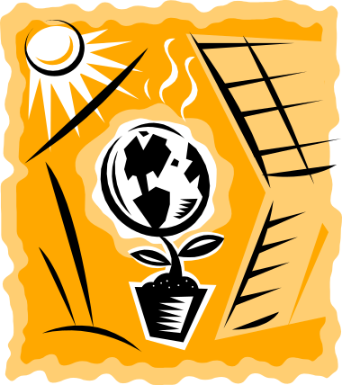
Energy

- How many different types of energy can you think of? List them in the space below.

- In plants, what is the name of the process that transfers solar energy to chemical energy (food).

- Write a chemical equation for this process.

- When you drink a glass of milk, it gives you energy. How did the energy get into the milk?

Over the last few weeks, we have been looking at energy transfer between different organisms. This mainly involves chemical energy which can be transferred into other types of energy. One form of energy our body uses is thermal energy.

- In your journals, glue in the KWL table (provided by your teacher), and write in your ideas about thermal energy in the first 2 columns. You might like to think about what thermal energy is and how it is transferred from one object to another.


